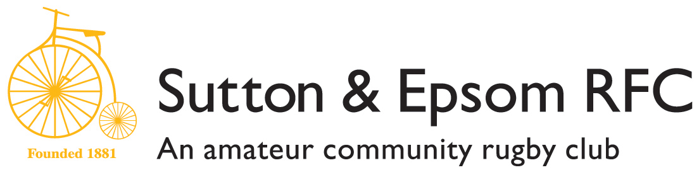

The Bike Ride
Tour de Cambridge 4th June 2017
120km of closed road Cycling

Dear All, members, friends, family,

As I hope you are all aware, Sutton & Epsom RFC originated in 1881 on the back of the Sutton Bicycle Club. In those days cycling was very much a summer sport so they needed something to keep them together during the winter period, hence SERFC was formed. Over the years, the rugby club grew to the club we are today, but we have never forgotten our humble beginnings.

To rekindle the spirit of yesteryear as a cycling club and a great opportunity to do a little fund raising, we have been given the opportunity to partake in the ‘Tour de Cambridge’!

The concept is simple; there are two levels of entry into the event:
- Raise £300 (+ any Gift Aid) as a Sponsorship package and ride for free; OR
- Pay £120 as a Donation to join the ride
  - Additionally should you wish to raise some funds knowing all the costs have been covered, you would be able to do so using this option
All riders will receive an Official Race Pack and Timing Chip, Cycling Shirt and access to the VIP area for pre race briefing, after race festivities and private changing facilities.

Either level of entry and donation would be hugely beneficial for the club; the more we raise (after costs are deducted) the greater the opportunities we can use the money to develop the club for the enjoyment of rugby to our children, local schools, clubs and for the wider community.

You’ll also get the chance to meet and greet the Atlas Foundation founder. He needs no introduction as a World Cup Winner in 2003, is better known to some as the ‘Fun Bus’, has 114 England Caps plus 5 British and Irish Lions caps, former Harlequin, Jason Leonard.

If you are interested, either as an age group, a team, as parents or just on your own then please get in touch with:

Rowland Cheall, Director of Rugby, Sutton & Epsom RFC
Phone number: 07776184383 / Email: rowlandcheall@outlook.com

OR

Neil Blewitt
Phone number: 07905120262 / Email: nblewitt@lseg.com

More information about the Atlas Foundation can be found at: www.theatlasfoundation.org.uk/

